# For Lease

Contact us:

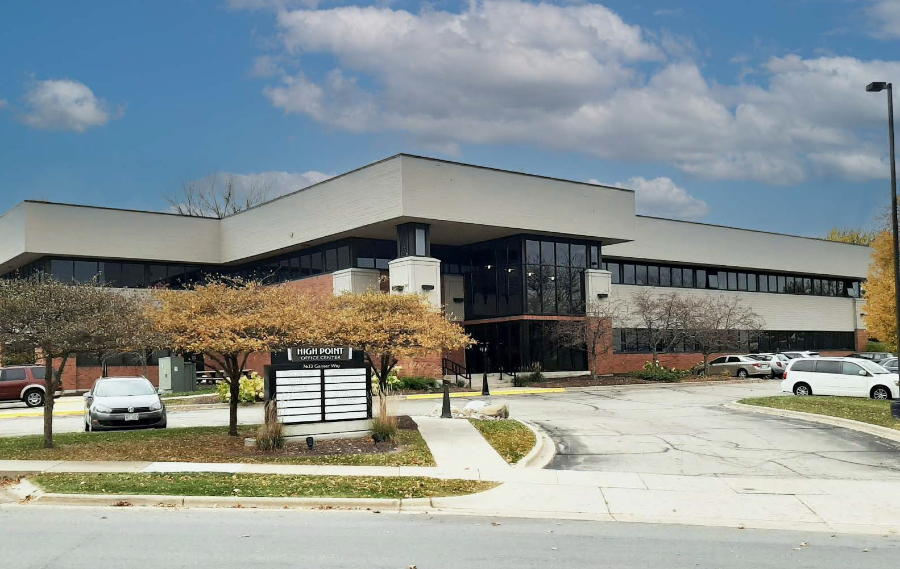

Chris Richards

Partner

+1 608 628 5895

[chris.richards@colliers.com](mailto:chris.richards@colliers.com)

Colin McLandsborough

Advisor

+1 262 309 5597

[colin.mclandsborough@colliers.com](mailto:colin.mclandsborough@colliers.com)

Colliers | Wisconsin

316 W. Washington Ave | Suite 925 Madison, WI 53703

P: +1 608 826 9500

F: +1 414 276 9501

7633 Ganser Way

Madison, WI 53719

Office Space at High Point Office Center

|  |  |
| --- | --- |
| Suite 102 | 1,461 SF  Available 5/1/25 |
| Suite 103 | 673 SF  Available 11/1/25 |
| Suite 104 | 792 SF  Available 07/01/2025 |
| Building Size | 29,000 SF |
| Lease Rate | $19.25 PSF Gross  *\*Tenant pays in-suite janitorial and phone/data* |

Property Highlights:

* Close proximity to area restaurants and shopping
* Close access to Mineral Point Road and Highway 12/14
* Generous surface parking for both visitors and tenants

Accelerating success.

7633 Ganser Way| For Lease

Floor Plan

# First Floor

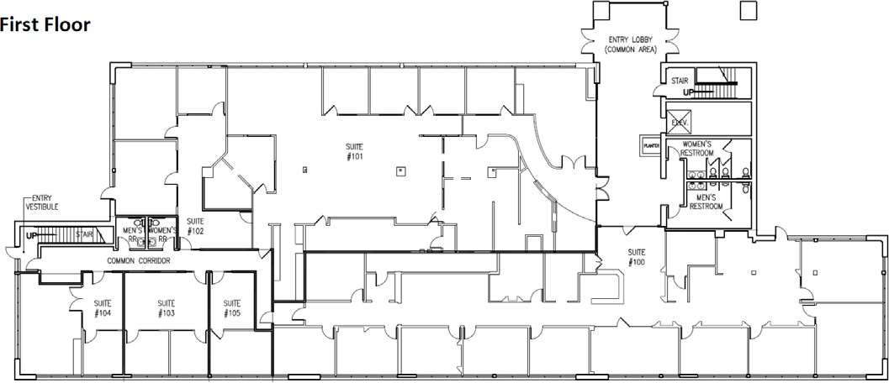

1,461 SF

|  |  |  |  |
| --- | --- | --- | --- |
|  |  |  | 673 SF |
| 792 SF | | |

7633 Ganser Way| For Lease

Area Amenities

12



14

West Towne Mall

MINERAL POINT ROAD

14

Demographics



|  |  |  |  |
| --- | --- | --- | --- |
| Population | Daily Population | Households | Household Income |
| 1 mi: 11,376 | 1 mi: 14,172 | 1 mi: 6,078 | 1 mi: $69,489 |
| 2 mi: 36,438 | 2 mi: 43,768 | 2 mi: 17,839 | 2 mi: $77,991 |
| 3 mi: 76,257 | 3 mi: 83,398 | 3 mi: 35,690 | 3 mi: $80,828 |

For Lease 60

7633 Ganser Way | Madison di

Lo

90

Pr Du Sac

|  |  |
| --- | --- |
|  |  |
| air | ie |

12

113

De

Forest

Sun Prairie

90

94

Contact

Chris Richards

Partner

+1 608 628 5895

[chris.richards@colliers.com](mailto:chris.richards@colliers.com)

Colin McLandsborough

Advisor

+1 262 309 5597

[colin.mclandsborough@colliers.com](mailto:colin.mclandsborough@colliers.com)

19

12 113

14

Middleton

14

78

Madison

Monona

Mt. Horeb

92

Verona

18 18

Fitchburg

51

14

69

78

Stoughton 51

92

59

New Glarus

14



Colliers | Wisconsin

316 W. Washington Ave | Suite 925 Madison, WI 53703

P: +1 608 826 9500

F: +1 414 276 9501

This document has been prepared by Colliers International for advertising and general information only. Colliers International makes no guarantees, representations or warranties of any kind, expressed or implied, regarding the information including,

but not limited to, warranties of content, accuracy and reliability. Any interested party should undertake their own inquiries as to the accuracy of the information. Colliers International excludes unequivocally all inferred or implied terms, conditions and warranties arising out of this document and excludes all liability for loss and damages arising there from. This publication is the copyrighted property of Colliers International and/or its licensor(s). ©2021. All rights reserved.

State Of Wisconsin | Disclosure to Non-Residential Customers

Prior to negotiating on your behalf the Brokerage firm, or an agent associated with the firm, must provide you the following disclosure statement:

## *Broker Disclosure to Customers*

You are a customer of the brokerage firm (hereinafter Firm). The Firm is either an agent of another party in the transaction or a subagent of another firm that is the agent of another party in the transaction. The broker or a salesperson acting on be- half of the Firm may provide brokerage services to you. When- ever the Firm is providing brokerage services to you, the Firm and its brokers and salespersons (hereinafter Agents) owe you, the customer, the following duties:

* The duty to provide brokerage services to you fairly and

To ensure that the Firm and its Agents are aware of what specific information you consider confidential, you may list that information below, or provide that information to the Firm and its Agents by other means. At a later time, you may also provide the Firm and its Agents with other information you consider to be confidential.

Confidential information:

Non-Confidential information: (The following information may

honestly.

* The duty to exercise reasonable skill and care in providing brokerage services to you.
* The duty to provide you with accurate information about market conditions with a reasonable time if you request it, unless disclosyre of the information is prohibited by law.
* The duty to disclose to you in writing certain Material Adverse Facts about a property, unless disclosure of the

be disclosed by the Firm and its Agents):

(Insert information you authorize to be disclosed, such as financial qualification information.)

## *Definition of Material Adverse Facts*

A “Material Adverse Fact” is defined in Wis. Stat 452.01 (5g) as an Adverse Fact that a party indicates is of such

information is prohibited by law.

* The duty to protect your confidentiality. Unless the law requires it, the Firm and its Agents will not disclose your confidential information or the confidential information to other parties.
* The duty to safeguard trust funds and other property held by the Firm or its Agents.
* The duty, when negotiating, to present contract proposals in an objective and unbiased manner and disclose the advantages and disadvantages of the proposals.

Please review this information carefully. An Agent of the Firm can answer your questions about brokerage services, but if you need legal advice, tax advice or a professional home inspection contact an attorney, tax advisor, or home inspector. This disclosure is required by section 452. 135 of the Wisconsin statues and is for information only. It is a plan-language summary of the duties owed to a customer under section

452.133 (1) of the Wisconsin statutes.

## *Confidentiality Notice to Customers*

The Firm and its Agents will keep confidential any information given to the Firm and its Agents in confidence, or any informa- tion obtained by the Firm and its Agents that a reasonable per- son would want to be kept confidential, unless the information must be disclosed by law or you authorize the Firm to disclose particular information. The Firm and its Agents shall continue to keep the information confidential after the Firm is no longer providing brokerage services to you.

The following information is required to be disclosed by law:

1. Material Adverse Facts, as defined in section 452.01 (5g) of the Wisconsin Statutes.
2. Any facts known by the Firm or its Agents that contradict any information included in a written inspection report on the property or real estate that is the subject of the transaction.

significance, or that is generally recognized by a competent licensee as being of such significance to a reasonable party, that it affects or would affect the party’s decision to enter into a contract or agreement concerning a transaction or affects or would affect the party’s decision about the terms of such a contract or agreement.

An “Adverse” fact is defined in Wis. Stat. 452.01 (1e) as a condition or occurrence that a competent licensee generally recognizes will significantly and adversely affect the value

of the property, significantly reduce the structural integrity of improvements to real estate, or present a significant health risk to occupants of the property; or information that indicates that a party to a transaction is not able to or does not intent to meet his or her obligations under a contract or agreement made concerning the transaction.

## *Sex Offender Registry*

Notice: You may obtain information about the sex offender registry and persons registered with the registry by contacting the Wisconsin Department of Corrections on the Internet at <http://offender.doc.state.wi.us/public/>

No representation is made as to the legal validity of any provision or the adequacy of any provision in any specific transaction.

Copyright 2016 by Wisconsin REALTORS Association.