Financials  Listed Price: $450,000  2024 Condominium Dues: $2,340  2023 Property Taxes: $3509.88  Utilities  Separately metered natural gas & electric service  Improvements  Landlord offers space in an “as is” condition with all mechanicals in good working order  Contact Jeff  (608)695-9597  shamrockllc@charter.net    7340 Darlin Dr. #18 Dane, WI 53529 |  |  | Features & Specifications  Radiant heat  2x200 amp Power 3 Phase  60’x65’ floor space  12’x14’ overhead door  Well and septic  Floor drain  Unisex restroom  Laundry sink  Load bearing mezzanine  Plenty of onsite parking available  Framed for additional overhead garage door  7340 Darlin Dr. #18 Dane, WI 53529 |  |  | 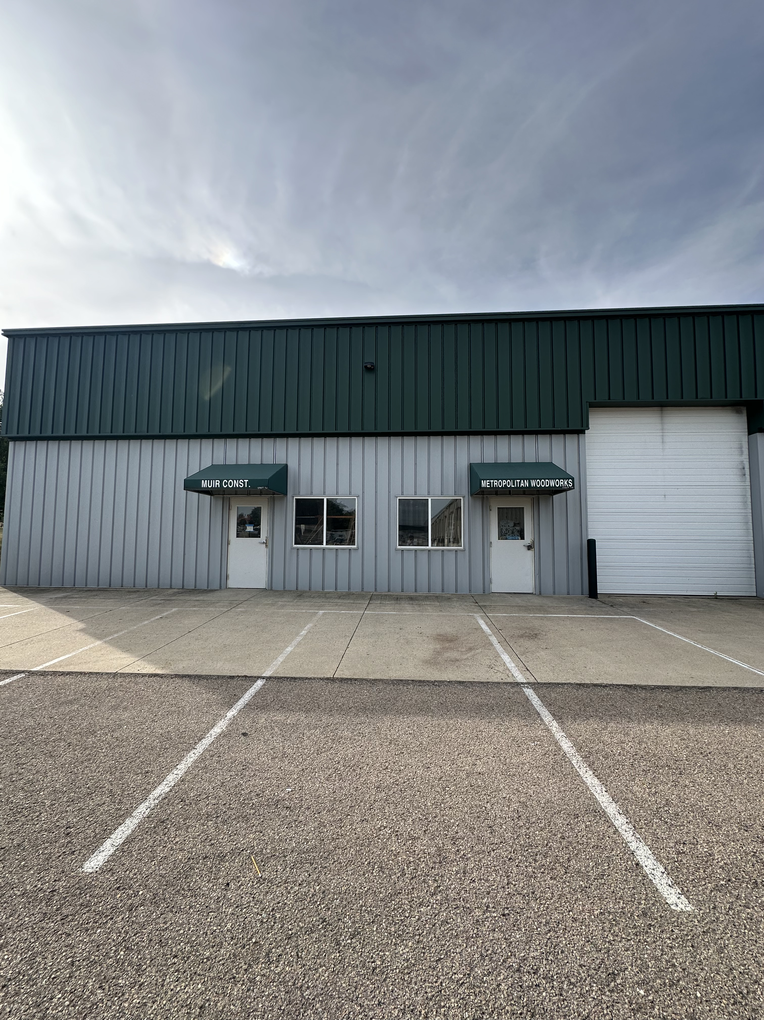  .  7340 Darlin Dr. #18 Dane, WI 53529  - Storage Condominium For Sale

