 | US BANK BUILDING
Property Data  Location 402 Gammon Place  Madison, WI  Building Three-Story Masonry and Glass Exterior  Gross Size 34,000 Sq. Ft.  Space  Available Suite 260: 399 SF  Suite 310: 248 SF  Suite 330: 810 SF  Amenities Common Conference Room, Break Room, Fitness Center with Showers and Lower Level Storage  - Contact -  MIKE RING  miker@parktowne.com  This property is being marketed by Park Towne Realty, LLC. | 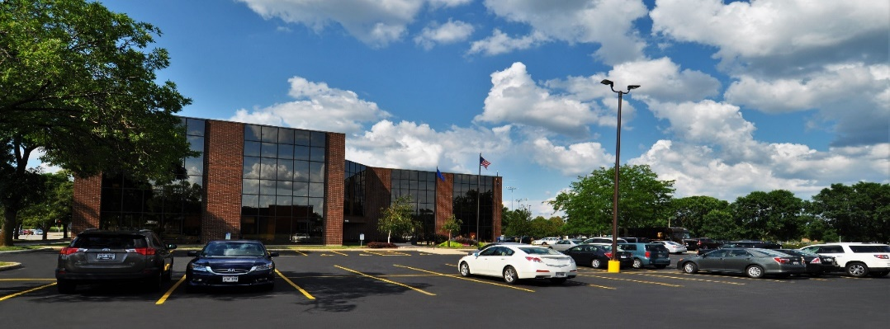  Lease space in one of the most recognizable buildings on Madison’s near west side. This building sits at the corner of Mineral Point Road and Gammon Road directly across the street from West Towne Mall. High traffic counts and easy accessibility make this an ideal choice for your office. Bus stops are located right at the building. Ample parking on site.  The building includes a common break room, conference room, fitness center with showers and lower level storage.  LEASE RATE & TERMS  Suite 260 $715.00 per month full gross  Suite 310 $445.00 per month full gross  These are single room offices. Great for a new start-up business. Short term leases available.  Suite 330 $1,282.50 per month modified gross  This is a nice office with four private offices and a reception area. Lease terms from one year to five years. The space will be available February 1, 2024.

