University Station

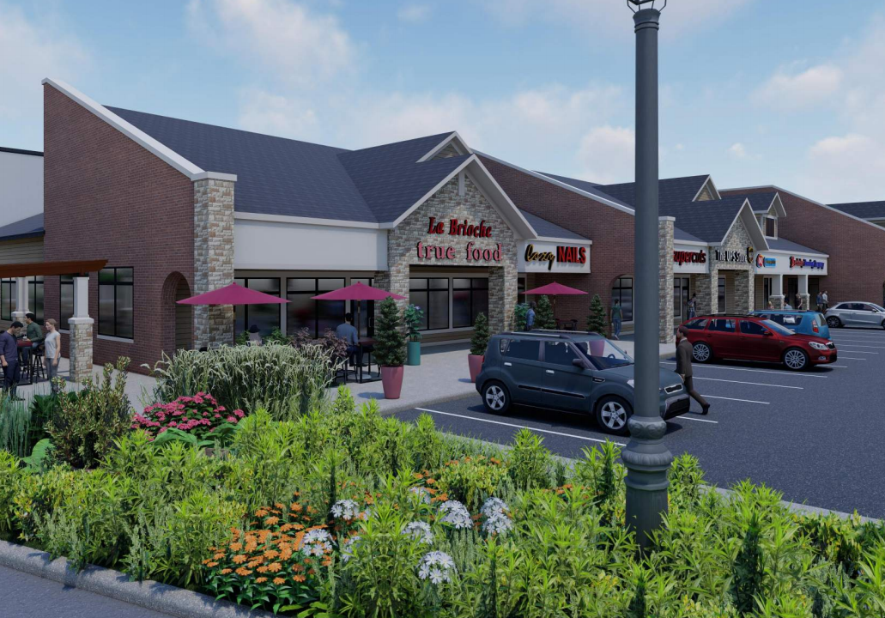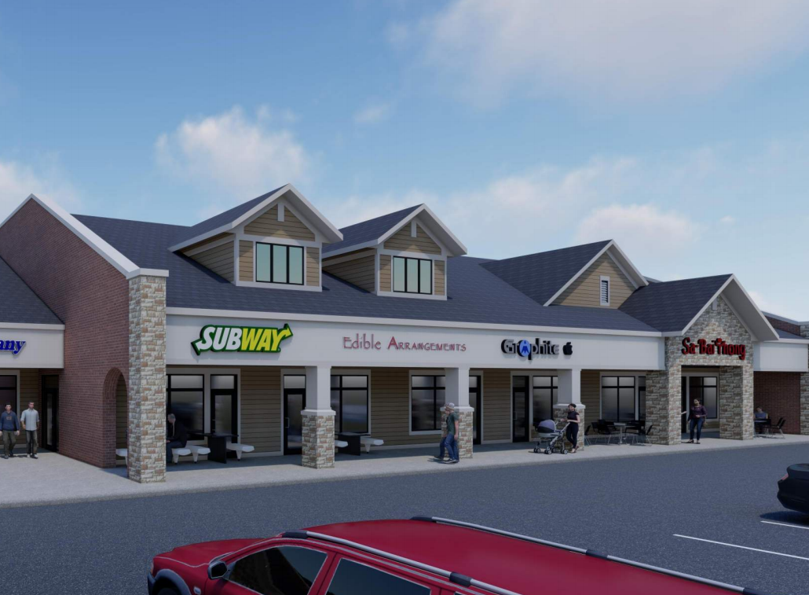
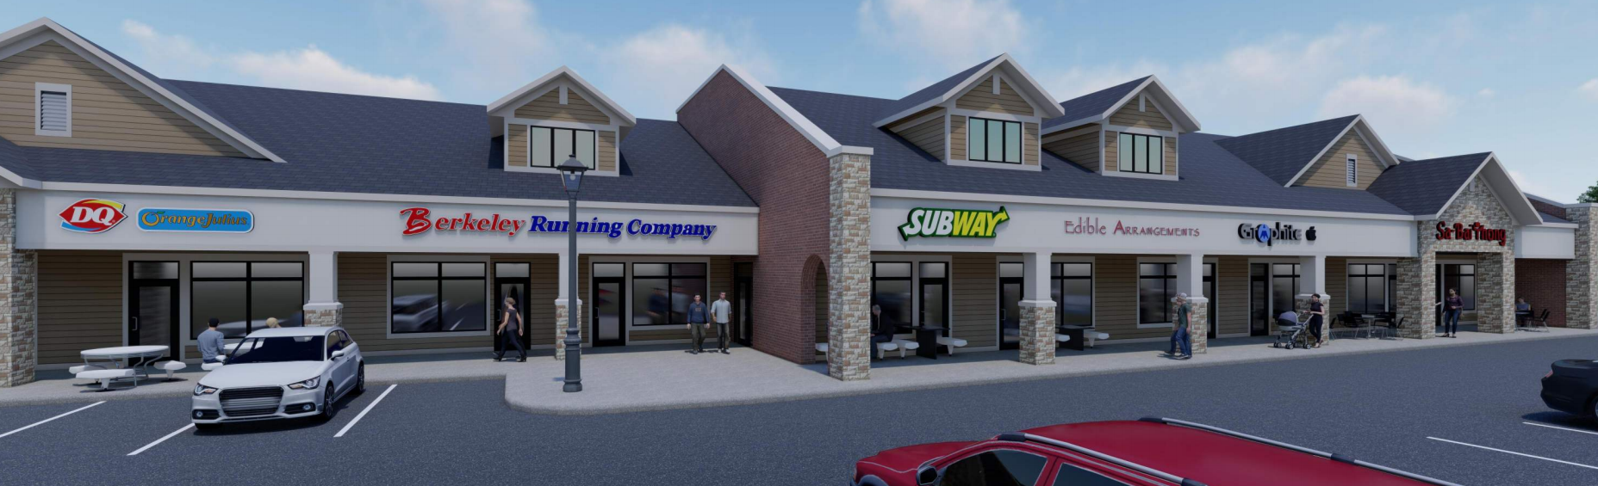
- 2852 University Avenue: University Station is ideally located on the near west side and offers great parking and visibility to over 55,000 cars per day.
- $1M+ renovation completed summer 2021 (renderings pictured above).
- Space available:
  - 3,968 square feet
- Base Rent = $20-$23/SF (depending on Tenant Improvement needs)
- NNN = $8.14


Brian J. Flad
Direct: 608.443.4365
bflad@flad-development.com

Thomas R. Romano
Direct: 608.443.4363
tromano@flad-development.com

Luke H. Thiele
Direct: 608.443.4362
lthiele@flad-development.com

