First Properties Business Park
Office Space For Lease

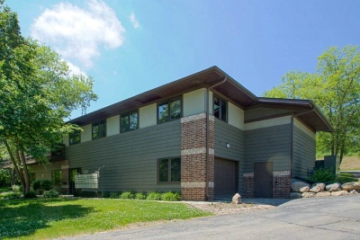
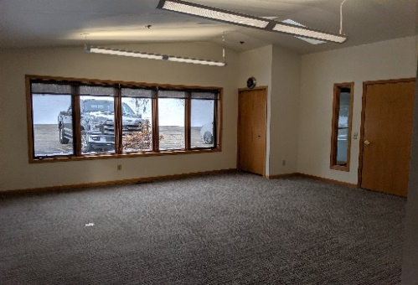
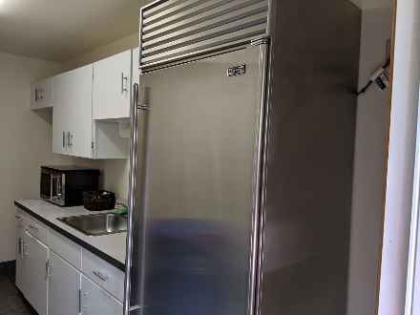
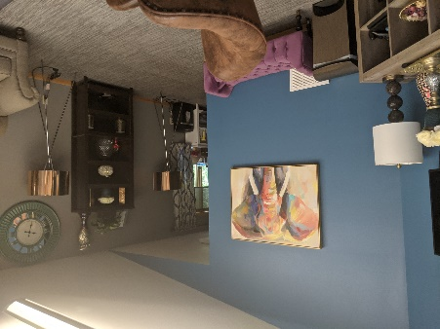
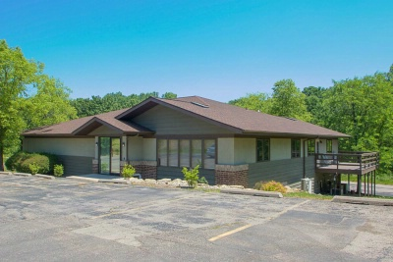

Suite 200 - 202
Available SF | Lease Rate | Building Class | Lease Type | Lease Term
872 sf | $1250/month | B+ | Gross | 3-5 Years
681 sf | $1025/month | B+ | Gross | 3-5 Years | 3-5 Years
191 sf | $350/month | B+ | Gross | 3-5 Years | 3-5 Years

SPACE OVERVIEW
Beautiful three room suite, vaulted ceilings, sky lights, in modern office building. Recently remodeled building with shared common kitchenette and waiting area. All utilities are included in the rental rate except internet.

FLOOR PLAN

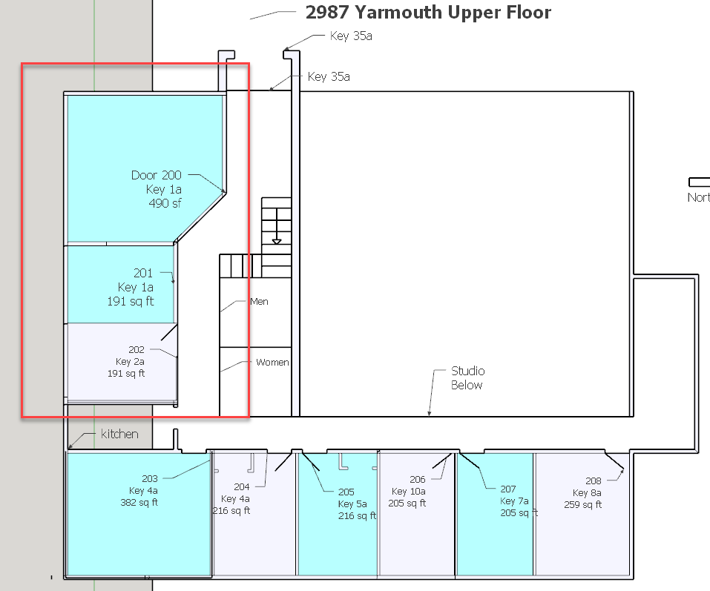
LOCATION OVERVIEW
- First Properties Business Park - a sylvan setting for a relaxing, updated office building
- Beautiful views of natural prairie green space
- Adjacent to Capital City bike trail, close to restaurants and coffee shops (2 blocks from Starbucks), just off McKee Road (Hwy PD) with easy access to Fish Hatchery Rd
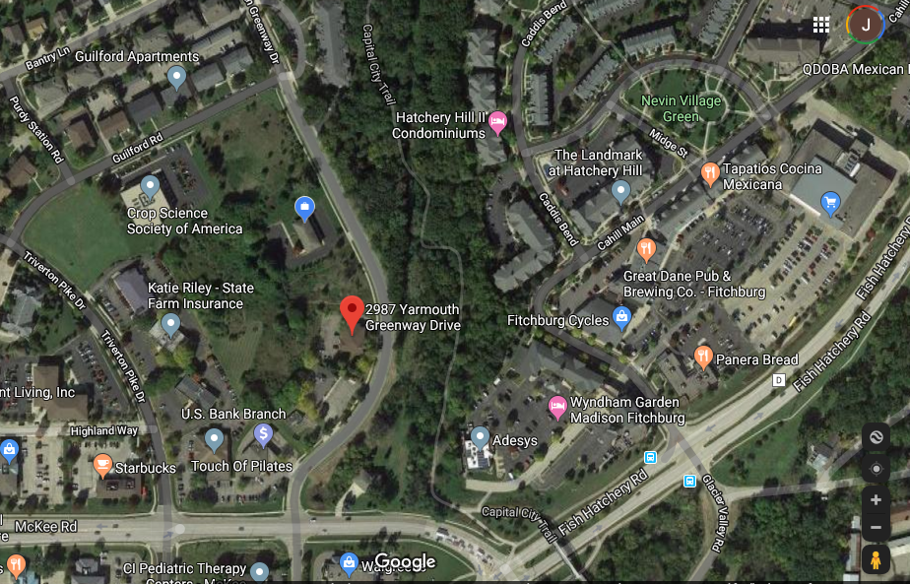
- Close to downtown and west side of Madison

